Test Case: tc001_SPX_Dev5_Crear_Requisicion_Spot_Tipo_Cobro_CC
Step 1 - Enter username and password and click to button Enter : Credentials Entered
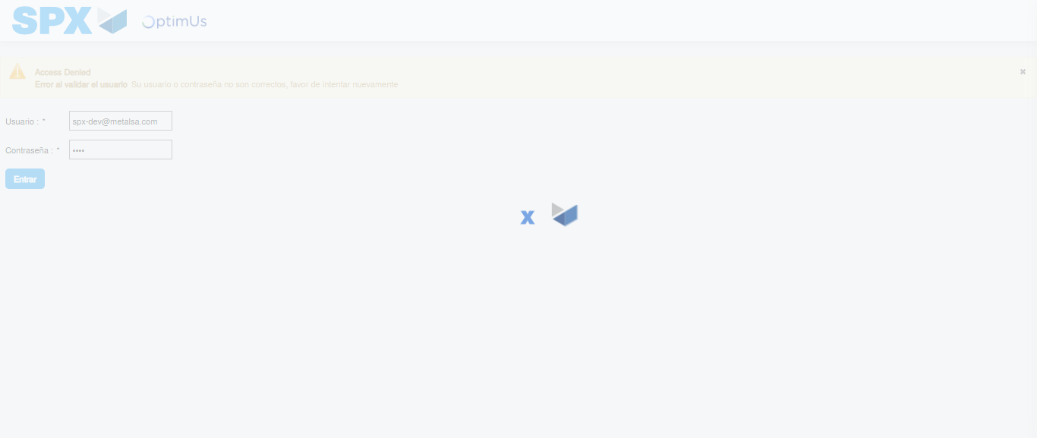Image file-name: QC_Testing-tc001_SPX_Dev5_Crear_Requisicion_Spot_Tipo_Cobro_CC-1783984400057

Step 2 - Select to UEN and Access to Spot Buy Requisitions : UEN Correctly selected and Correct access
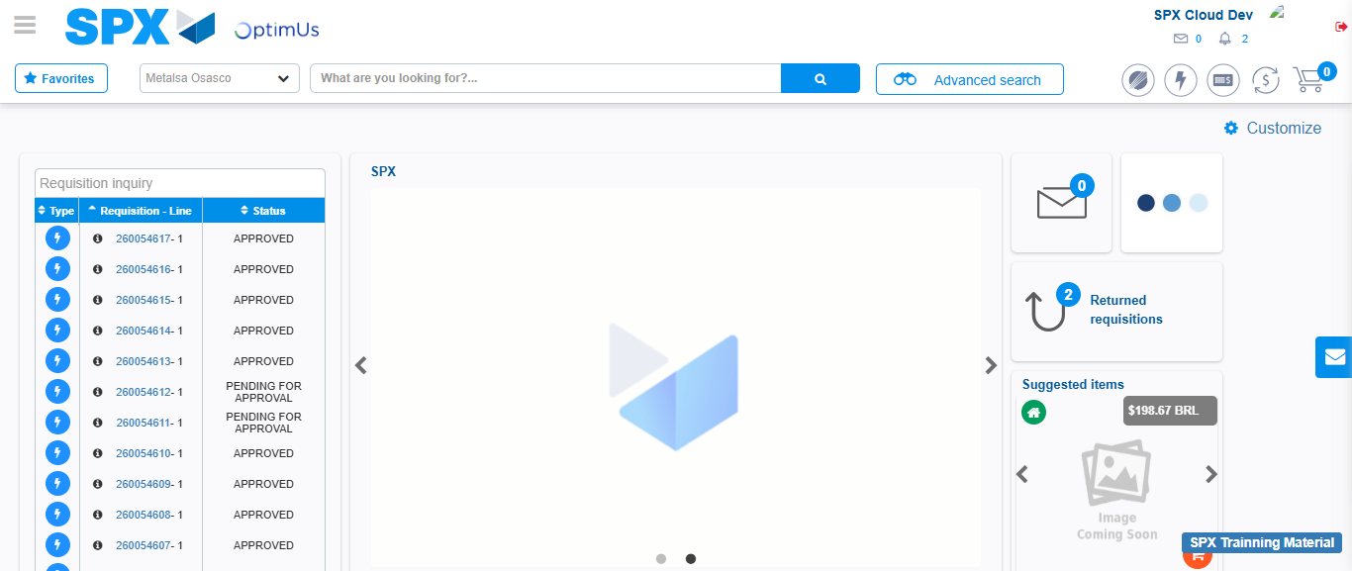Image file-name: QC_Testing-tc001_SPX_Dev5_Crear_Requisicion_Spot_Tipo_Cobro_CC-1783984426737

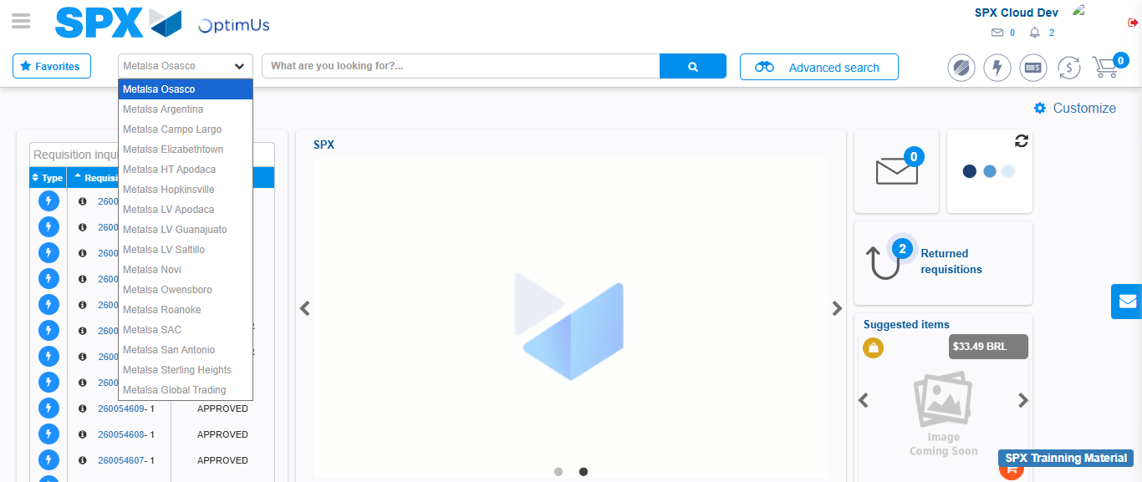Image file-name: QC_Testing-tc001_SPX_Dev5_Crear_Requisicion_Spot_Tipo_Cobro_CC-1783984429305

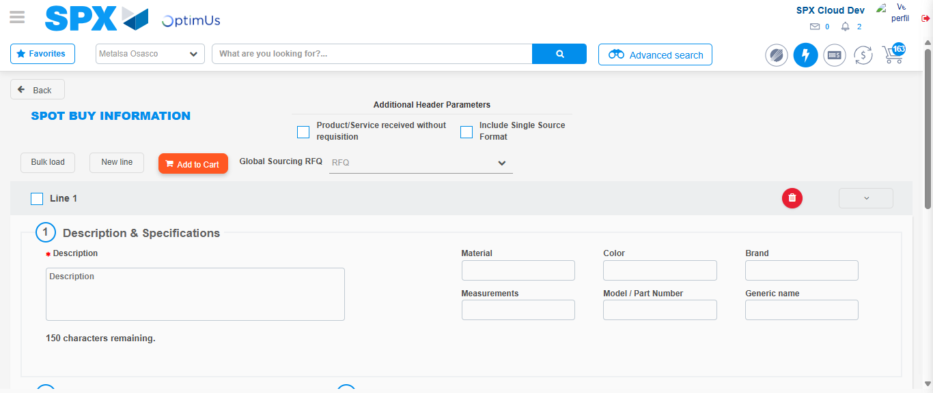Image file-name: QC_Testing-tc001_SPX_Dev5_Crear_Requisicion_Spot_Tipo_Cobro_CC-1783984452416

Step 3 - Data Capture Spot Buy Requisition : Data captured correctly
Image file-name: QC_Testing-tc001_SPX_Dev5_Crear_Requisicion_Spot_Tipo_Cobro_CC-1783984452731

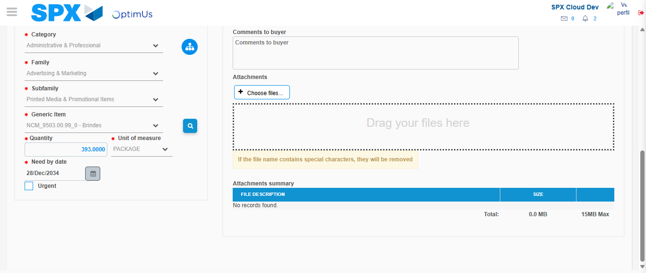Image file-name: QC_Testing-tc001_SPX_Dev5_Crear_Requisicion_Spot_Tipo_Cobro_CC-1783984465857

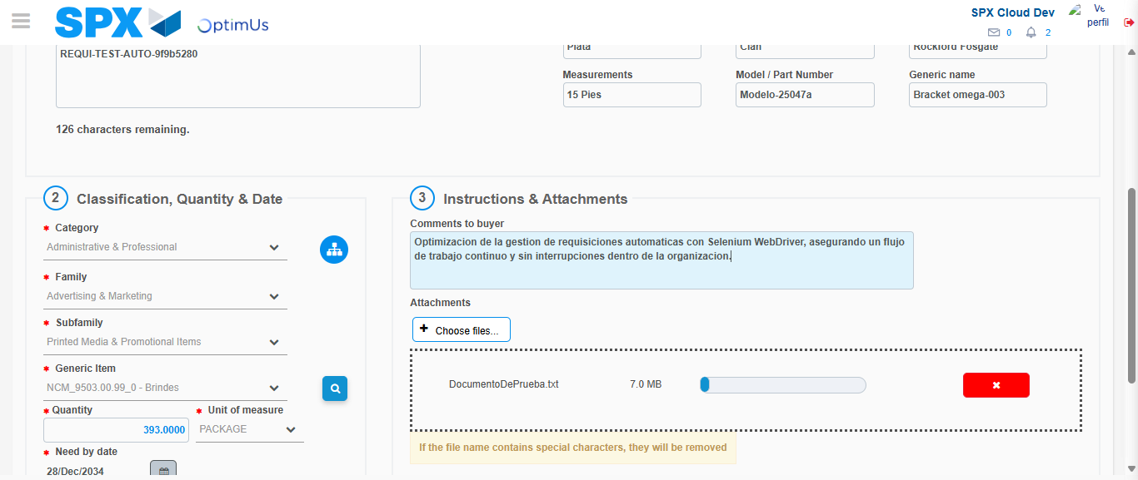Image file-name: QC_Testing-tc001_SPX_Dev5_Crear_Requisicion_Spot_Tipo_Cobro_CC-1783984466856

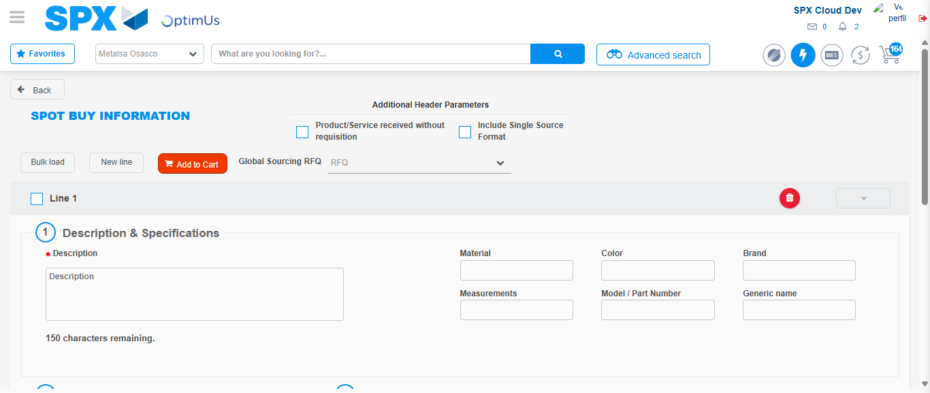Image file-name: QC_Testing-tc001_SPX_Dev5_Crear_Requisicion_Spot_Tipo_Cobro_CC-1783984473857

Step 7 - Return to Main Page SPX : Return to Main Page SPX
Image file-name: QC_Testing-tc001_SPX_Dev5_Crear_Requisicion_Spot_Tipo_Cobro_CC-1783984426737

Image file-name: QC_Testing-tc001_SPX_Dev5_Crear_Requisicion_Spot_Tipo_Cobro_CC-1783984429305

Image file-name: QC_Testing-tc001_SPX_Dev5_Crear_Requisicion_Spot_Tipo_Cobro_CC-1783984452416

Image file-name: QC_Testing-tc001_SPX_Dev5_Crear_Requisicion_Spot_Tipo_Cobro_CC-1783984476119

Image file-name: QC_Testing-tc001_SPX_Dev5_Crear_Requisicion_Spot_Tipo_Cobro_CC-1783984476331

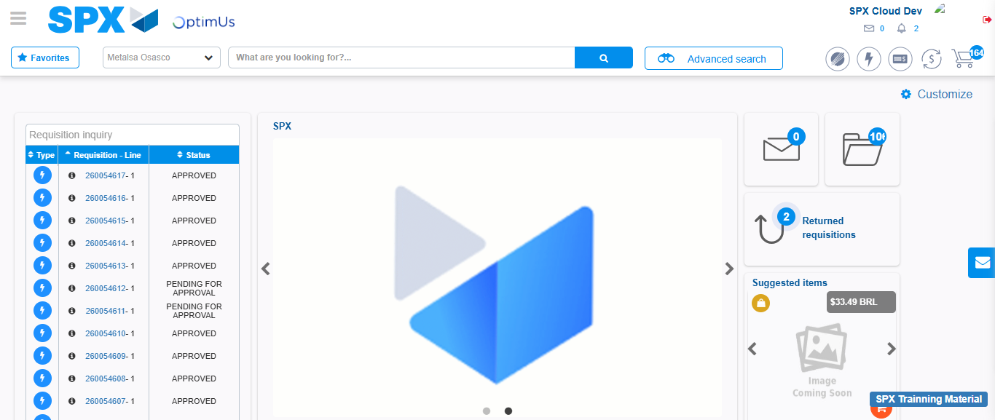Image file-name: QC_Testing-tc001_SPX_Dev5_Crear_Requisicion_Spot_Tipo_Cobro_CC-1783984497643

Step 8 - Log Out : Log Out SPX
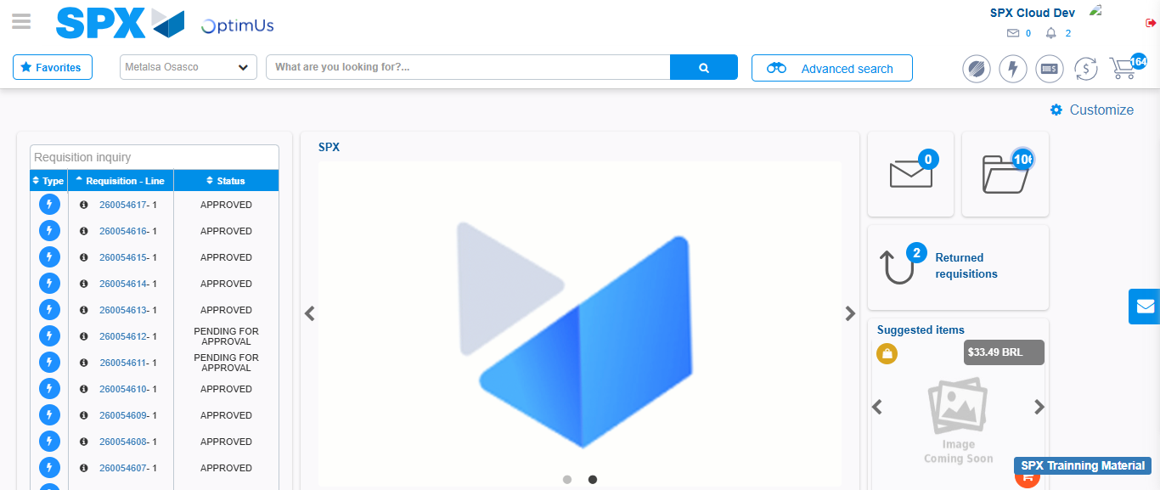Image file-name: QC_Testing-tc001_SPX_Dev5_Crear_Requisicion_Spot_Tipo_Cobro_CC-1783984498013

